A Food Lover’s Guide to Canada

Label the map below and for each province colour it/ draw pictures or write words for foods and important information about that province/territory:

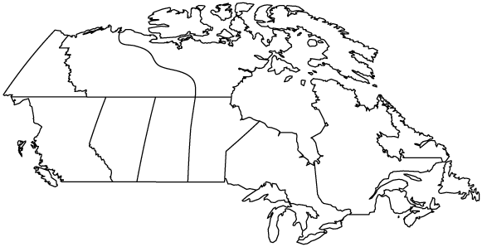

Summarize Important Information on each Province/Territory

Newfoundland and Labrador

Prince Edward Island

Nova Scotia

New Brunswick

Quebec

Ontario

Manitoba

Saskatchewan

Alberta

British Columbia

Yukon

Northwest Territories

Nunavut

