Diets

- Dieting: Cutting out certain foods, eating more of other foods, cutting back on calories overall, using diet pills or supplements, following a plan that promises ________________________________________________________

- People that go on and off diets all the time may never establish ___________________________________________________________________

- ______________________________ dieting or weight cycling, refers to a pattern of rapid weight loss and gain.

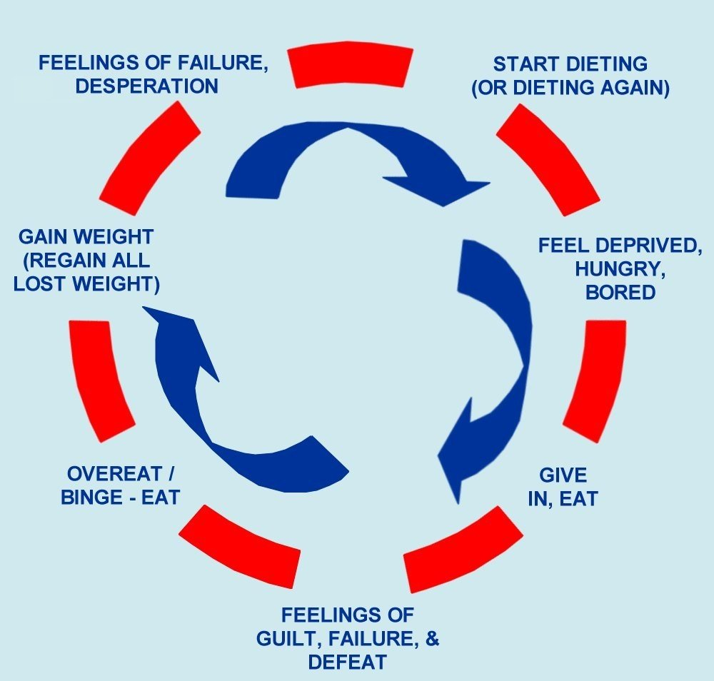
Cycle of Dieting

Fad Diets

- Popular weight-loss methods that ___________________ sound nutrition principles.
- RISKY
- Promise ____________________ and ______________________ weight loss

Disadvantages of Diets
- Frauds
- Cost
- Limited food choices/lack of variety
- Lack of important nutrients
- Most gain it back....plus more
To Watch out For:

- Very low-calorie (___________________calories or less per day)
- Eating plans based on a ___________________________, such as grapefruit or cabbage soup
- _______________________ diets that are low in calories
- _______________________– going without food
- ________________________ – create health problems
- Plans that promise __________________ weight-loss (over two pounds per week)

Based on Everything we have learned this year – what are some ways that people can manage their weight successfully and healthily?

