FATS – Lipids

Lipids = a family of _____________________that are a main component of every living cell.
-Like carbohydrates, composed of_______________, __________________, and_____________________.
-Lipids contain many more carbons and hydrogens in proportion to their oxygens, so can supply more _____________ per gram (Remember: 9 calories per gram)

The Lipid Family
The Family includes:
- ____________________: ‘head’ of the family as they predominate in both foods and in the body. They include nearly all of the fats and oils people typically eat.
- ____________________: used as an emulsifier that mix fats with water, and found naturally in food.
- ____________________: include bile acids, some hormones, and cholesterol.

TRIGLYCERIDES
Main Function: ___________________________

Composed of three fatty acids (carbon chain with hydrogens attached) attached to a glycerol (backbone to a triglyceride)

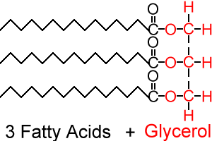

The chemistry of a fatty acid influences the characteristics of foods and the health of the body, which brings us to Types of Fats!

Fatty acids differ by:
- _______________________________
- _______________________________
- _______________________________

Types of Fats:

___________________Fats
- Molecules have ______________________
- Contain all of the _____________________atoms their molecular structure can hold – linked to ____________________________
- These chains are fairly straight and can ________________ closely together, making these fats _____________at room temperature (i.e., lard, butter – animal fats)
- Found mostly in _____________________________________________________
- Intake should be limited

________________________Fat
- Has at least ____________________ between carbons
- ____________________ hydrogen atoms – to make up the difference for a missing single bond, a ____________________forms.
- Double bonds cause the molecule to bend.
- The kinks in the tails mean that unsaturated fats can't ___________as closely together, making them ________________at room temperature (i.e., vegetable oil)
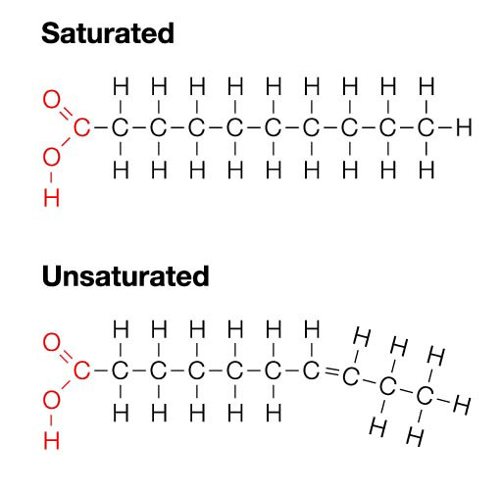
Types of Unsaturated Fats
________________________Fats
- Carbon molecules with at least ______________________
- Found primarily in olive oil and canola oil
- Recommended as a replacement for __________________
________________________Fats
- Carbon molecules with at least ______________________________
- Found mainly in vegetable oils (safflower, sunflower, corn, soybean, cottonseed)
- Contain essential fatty acids: _____________________________

Essential Fatty Acids:
- Omega-3 fatty acids_– Necessary for human health for the body can’t make them
- Research shows that omega-3 fatty acids reduce ____________________and may help lower risk of chronic diseases such as _____________________________________________________________________________________________

- Omega –6 fatty acid – Are highly concentrated in the brain and appear to be important for cognitive (brain memory and performance) and behavioural function (
- Shown to lessen the risk of heart disease
(food sources: fish, flaxseed, leafy greens, eggs)
Oxidation, Hydrogenation and Trans – Fats
Oxidation
- Occurs as surface of the foods reacts with ________________
- When fatty acids oxidize, they ___________________ by combining with oxygen
- Main reason that high-fat foods spoil
- Unsaturated fats with more double bonds (which make them more unstable) are _____________________________
Hydrogenation
- A chemical process in which _______________is _______________to unsaturated fat molecules, breaking some double bonds and replacing them with single bonds.
- It _______________against oxidation by making polyunsaturated fats more ________________________
- It alters the texture of foods by making _______________vegetable oils more ___________________(i.e., margarine and shortening)

Trans-Fat
- Hydrogenation gives rise to trans-fatty acids – altered fatty acids that may have health effects similar to saturated fats.
- Occur when oils are partially hydrogenated and some of the unsaturated fatty acids change their shape – artificially created chemical process
- Found in many processed foods that contain partially hydrogenated fats (some margarines, cookies, crackers, french fries, potato chips)
- Can raise _____________________levels, increase risk for __________________
Meeting your Fat Needs
- Generally we consume too much fat in our diets
- Canadian Dietitians recommend we include between ___________% of energy as fat
- Eating fat does __________mean you are going to_____________.
- It is the number of _______________(more energy in than out) that causes an increase in___________________.
Functions of Fats
- The main function of fats in the body is to__________________:
  - By supplying energy, fats save _______________from being used for energy and allow them to perform their more important role of building and repairing tissues
- Fats can also be stored in body for subsequent use (______________)
- Help in forming structural material of cells and tissues such as the________________.
  - Protect our ________________from harm
- Carry the fat soluble vitamins ____________________into the body and help in the ____________________of these vitamins in the intestines.
- Some fats supply essential ______________
Understanding the Fat Issue
- Heart disease is Canada’s number _______ killer
- Hardening of the __________ is one of the most common types of heart disease
- Fatty deposits on the inner lining of the artery walls reduce the artery’s total diameter (blockage or atherosclerosis), _____________ the flow of blood, causing _____________by blood clot = heart attack or stroke
- _____________ diet helps to eliminate this risk

Controllable Risk Factors
- High blood cholesterol levels
- Smoking
- Lack of exercise
- High blood pressure
- Stress
- Obesity
Uncontrollable Risk Factors
- Heredity
- Gender
- Age
- Diabetes

