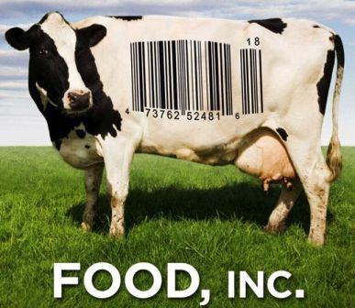
Name: ________________________

Food Inc. lifts the veil on the food industry. Food Inc. reveals surprising – and often shocking truths – about what we eat, how it’s produced and who we have become as a society. *Warning: Contains some disturbing and sensitive content.
- Topics found in this movie include: food production, food processing, food safety, livelihood of the farmer, safety of workers, food safety & food-borne illness, environmental impacts, genetically modified foods, labelling, obesity, fast food, and more.

Fast Food to All Food
- What did McDonald’s do in the 1930s in terms of changes to fast food?
____________________________________________________________________________________________________________________________________________________________________________________________________________________________________________________________________________________________________________________

- How have the way chickens been raised changed (1950 vs. 2008)? Why is this?
____________________________________________________________________________________________________________________________________________________________________________________________________________________________________________________________________________________________________________________

A Cornucopia of choices
- Why is there so much corn produced?
____________________________________________________________________________________________________________________________________________________________________________________________________________________________________________________________________________________________________________________

- What is CAFO? Explain.
_______________________________________________________________________________________________________________________________________________________________________________________________________________________________________

- What is found to happen when cows eat a diet high in corn? How does it affect our meat?
____________________________________________________________________________________________________________________________________________________________________________________________________________________________________________________________________________________________________________________

Unintended consequences
- What is the link between the FDA (Food & Drug Administration) and food safety issues?
____________________________________________________________________________________________________________________________________________________________________________________________________________________________________________________________________________________________________________________

- What is one way the meat factories try to combat e. Coli?
__________________________________________________________________________________________________________________________________________________________
The dollar menu
- Why is obesity linked to income? What is stopping families from eating healthy foods and choosing fast food?
_________________________________________________________________________________________________________________________________________________________________________________________________________________________________________________________________________________________________________________________________________________________________________________________________

- Humans are hard-wired to go for three tastes:
_____________________ ________________________ _________________________

In the grass
- Based on the natural farmer’s comments, do you think this way of food production is possible today? _______________________________________________________________________
_______________________________________________________________________________________________________________________________________________________________________________________________________________________________________

- How is food production related to how workers are treated/the work environment? (Give examples). ____________________________________________________________________
____________________________________________________________________________________________________________________________________________________________________________________________________________________________________________________________________________________________________________________

Hidden costs
- Why are companies like Wal-Mart getting behind organic products?
_______________________________________________________________________________________________________________________________________________________________________________________________________________________________________

From seed to the supermarket
- What is a reason why farmers do not use their seeds anymore?
____________________________________________________________________________________________________________________________________________________________________________________________________________________________________________________________________________________________________________________

- Why is it that so many farmers conform to corporations like Monsanto?
____________________________________________________________________________________________________________________________________________________________________________________________________________________________________________________________________________________________________________________

The veil
- What is the link between the US government and the food industry?
____________________________________________________________________________________________________________________________________________________________________________________________________________________________________________________________________________________________________________________

- Why is the FDA against labelling GMO foods/fast foods?
____________________________________________________________________________________________________________________________________________________________________________________________________________________________________________________________________________________________________________________

Shocks to the system
- How is oil related to food prices?
____________________________________________________________________________________________________________________________________________________________________________________________________________________________________________________________________________________________________________________

- According the film, what could be a ‘real’ goal for the food industry? What do you think of this goal? ________________________________________________________________________
____________________________________________________________________________________________________________________________________________________________________________________________________________________________________________________________________________________________________________________

- Based on some of the ideas written at the end of the film; please list and describe TWO of them, and how YOU could make a change based on that idea (4 marks).

Total /19 (1 Mark per Question)

