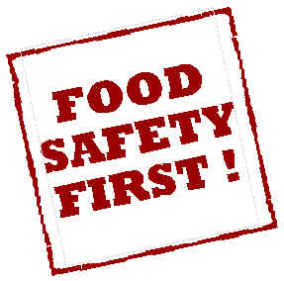
Food Safety Matters – Notes

- Why Study Food Safety?

- Who is responsible for food safety?

- Who benefits when food safety it practiced?

Clean
Cook
Separate
Chill

- Hand washing:

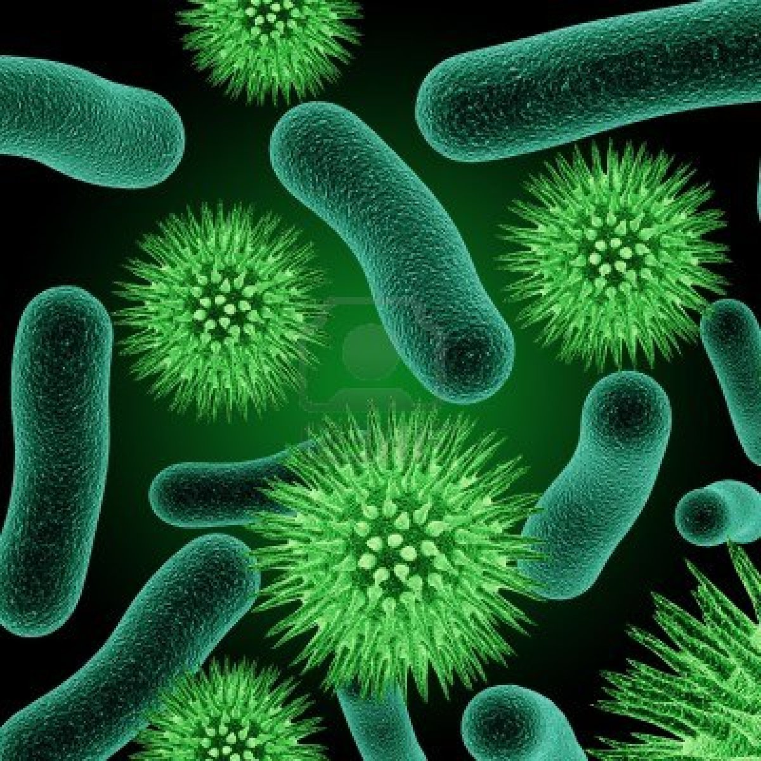
- What you need to know about bacteria:

Pathogen:

- Cross-Contamination:

- The Danger Zone:
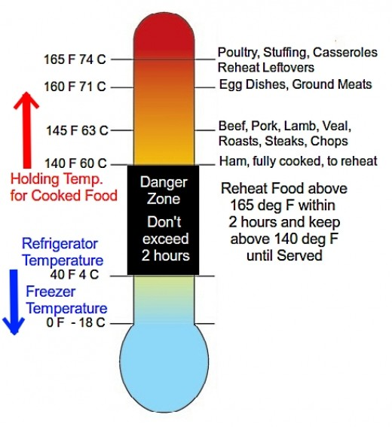

- Food Borne Illness:

- Thawing:

