FOREIGN COOKING EQUIPMENT

Equipment Name | Descriptions and Types | How to use it | Where it is used
Mandolines
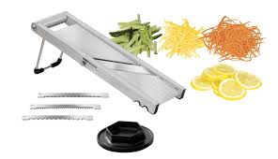

Mortars and Pestles
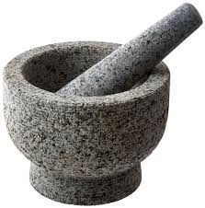

Woks

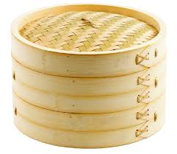
Steamers and Steaming Baskets

Tortilla and Chapati Presses
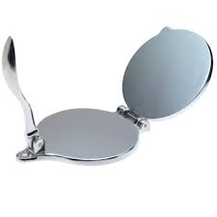

Sushi Equipment
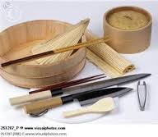

Specialty Casseroles
