Functional Foods

Functional Foods are ___________________________________

Put a star next to the ones you eat regularly

- Beans
- Berries
- Cruciferous vegetables
- Chocolate
- Citrus fruits
- Pumpkin
- Fish
- Soy
- Spinach
- Sweet Potatoes
- Tea
- Tomatoes
- Nuts
- Whole grains
- Yogurt

Key Terms

__________________________________– a food that can help to promote health in humans

__________________________________– chemicals found naturally in many plant products that act as antioxidants which prevent free radical damage in the body.

___________________________________– water-soluble plant pigments (from colourful vegetables and fruit) that are beneficial to human health.

__________________________________– natural chemicals found in foods that helps to prevent degradation due to free radicals (rebellious ions).

___________________________________– the degree to which the human body can make use of a substance once it has been ingested.

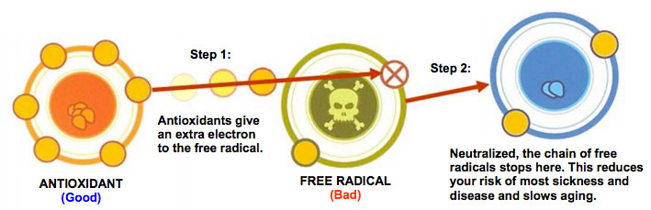

Watch video: https://www.youtube.com/watch?v=lG3OOXIXvxw

What is a free radical?

What creates free radicals in the body?

What is oxidative stress? And what can it cause?

How do antioxidants work?

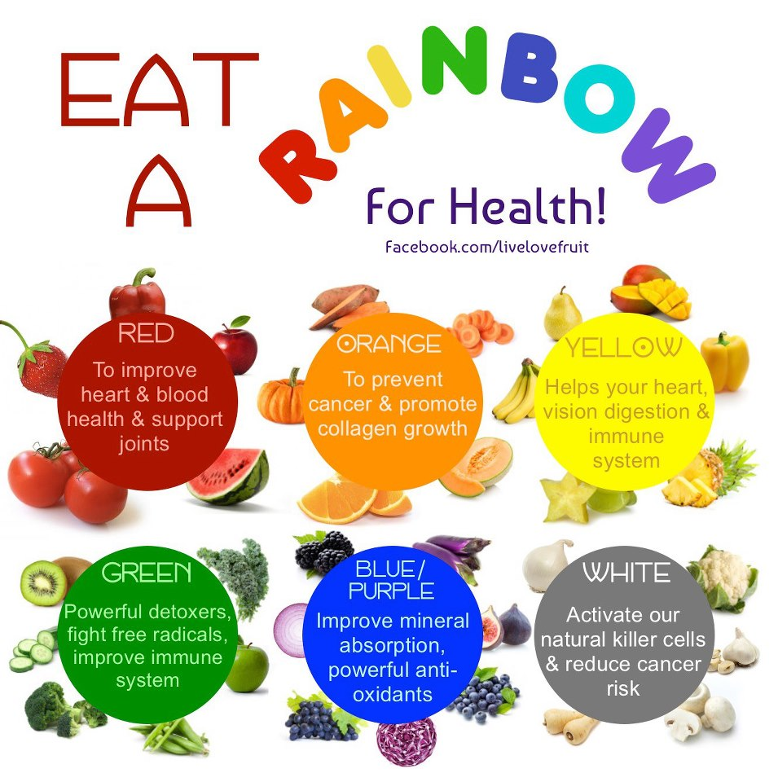

For each functional food dot jot a few key points:

Beans

Berries

Cruciferous vegetables

Chocolate

Oranges/Citrus

Pumpkin

Fish
Soy

Spinach Sweet Potatoes

Tea

Tomatoes

Nuts

Whole Grains

Yogurt

