##### Learngrowsucceedlogo

##### ***Nutrition and Health, Grade 12 HFA4U***

|  |  |  |
| --- | --- | --- |
| Teacher: Ms. Smith | Email: smitham@hdsb.ca | Website: [www.smitham1.weebly.com](http://www.smitham1.weebly.com) - password: mssmitham |
|  |  |

This course examines the relationships between food, energy balance, and nutritional status; the nutritional needs of individuals at different stages of life; and the role of Nutrition in health and disease. Students will evaluate nutrition-related trends and will determine how food choices can promote food security and environmental responsibility. Students will learn about healthy eating, expand their repertoire of food-preparation techniques, and develop their social science research skills by investigating issues related to nutrition and health.

Prerequisite: Any university or university/college preparation course in social sciences and humanities, English, or Canadian and world studies

## Curriculum

***Students final report card grade will be based on the evidence provided of these overall curriculum expectations:***

A1. Exploring: explore topics related to nutrition and health, and formulate questions to guide their research;

A2. Investigating: create research plans, and locate and select information relevant to their chosen topics, using appropriate social science research and inquiry methods;

A3. Processing Information: assess, record, analyse, and synthesize information gathered through research and inquiry;

A4. Communicating and Reflecting: communicate the results of their research and inquiry clearly and effectively, and reflect on and evaluate their research, inquiry, and communication skills.

B1. Nutrients: demonstrate an understanding of nutrients and their connection to physical health;

B2. Food Guides: demonstrate an understanding of Canada’s Food Guide and its role in promoting physical health;

B3. Energy Balance: demonstrate an understanding of the physical processes involved in maintaining energy balance;

B4. Nutritional Status: demonstrate an understanding of their nutrient intake and of factors that affect the nutritional status of individuals and groups.

C1. Nutrition throughout the Lifespan: demonstrate an understanding of food- and nutrition-related issues at different stages in the lifespan;

C2. Nutrition and Disease: demonstrate an understanding of the relationships between nutrition, health, and disease;

C3. Trends and Patterns in Food and Nutrition: demonstrate an understanding of current Canadian trends and patterns in nutritional guidelines and in food production and consumption.

D1. Food Security: demonstrate an understanding of various factors involved in achieving and maintaining food security;

D2. Food Production and Supply: demonstrate an understanding of various factors that affect food production and supply;

D3. Food Production and the Environment: demonstrate an understanding of the impact of food production on the environment.

E1. Kitchen Safety: demonstrate an understanding of practices that ensure or enhance kitchen safety;

E2. Food Safety: demonstrate an understanding of practices that ensure or enhance food safety;

E3. Food Preparation: demonstrate skills needed in food preparation.Your Report Card Grade will be determined as follows:

|  |  |
| --- | --- |
| **Term work:**  **70%** of your grade will be based on all of the evidence you have provided. It will reflect your most consistent level of achievement with special consideration given to more recent evidence. | 17.5% **Knowledge & Understanding**: Emphasizes the ability to recall factual information, recognize fundamental concepts and the foundational skills of the subject/discipline.  17.5% **Application**: Emphasizes the application and integration of knowledge, skills, processes and techniques to produce evidence of the student’s understanding.  17.5% **Thinking**: Emphasizes the thinking skills used in thinking processes to demonstrate the student’s understanding of information they have processed.  17.5% **Communication**: Emphasizes the clear, precise and effective use of oral, written and visual language to communicate the student’s understanding of information and ideas. |
| **Final Evaluation:**  **30%** of your grade will be determined at the end of the course. | 10% **Performance Task** |
| 20% **Written Exam** |
| Your **final grade** will be calculated by combining your Term (70%) grade and your Exam and Performance Task Evaluations (30%). | |

## Academic Standards

It is your responsibility to provide evidence of your learning within established timelines. Due dates for assignments and the scheduling of tests will be communicated well in advance to allow you to schedule your time. If you aren’t going to be able to follow an agreed upon timeline you should demonstrate your responsibility and organizational skills by discussing with your teacher the challenges you’re facing as far in advance of the deadline as possible.

It is your responsibility to be academically honest in all aspects of your schoolwork so that the marks you receive are a true reflection of your achievement.

Plagiarism is using the words, ideas or work of someone else without giving appropriate credit to the original creator. This is a form of cheating.

Consequences for not meeting these academic standards may include:

* Reporting the issue to your parents;
* Requiring you to complete the original or alternative work after school or during your lunch hour;
* Requiring you to complete an alternative assignment;
* Suspension;
* Assigning a “zero” for an assignment not completed prior to an agreed upon closure date;
* Mark deduction of 5% / day.

**NOTE:** the complete HDSB policies and administrative procedures for “Lates and Missed Assignments” and “Cheating and Plagiarism” policies may be found at [www.hdsb.ca](http://www.hdsb.ca)

|  |  |  |  |
| --- | --- | --- | --- |
| **Units** | **Curriculum Focus** | **Major Assignments / Evaluations** | **Key Resources** |
| **1 Food and Kitchen Safety** | Enduring Learning:  8, 9 | Food Safety Article Assignment  Kitchen Know-How Assignment  Food Safety Test | canfightbac.org  Teacher-developed resources |
| **2 Nutrition and Health: Keeping You Healthy** | Enduring Learning:  1, 2, 4, 8, 9 | Nutrient Deficiency Spotlight  Food Label Investigation  Personal Food Record  Recipe Makeover Assignment  Hungry For Change Film Review  Nutrient Needs Lab  Nutrition Test | Canada’s Food Guide and other Nutrition Guidelines  Nutrient Values of Some Common Foods  Fitday.com or other nutritional analysis programs |
| **3 Eating Patterns and Trends: Keeping Others Healthy** | Enduring Learning:  3, 4, 5, 8, 9 | Life Cycle Nutrition Workshop  Food Trend Investigation and Report  Functional Foods Lab and Slide Show  Book Review  Test | Teacher-developed resources |
| **Local and Global Food Issues** | Enduring Learning  6, 7, 8, 9 | Spotlight on Food Security  Food Inc. Film Review  Share and Respond | Teacher-developed resources |
| **Summative** |  | Cooking Show |  |

## Learning Skills & Work Habits

These learning skills and work habits will be taught, assessed and evaluated throughout the course.

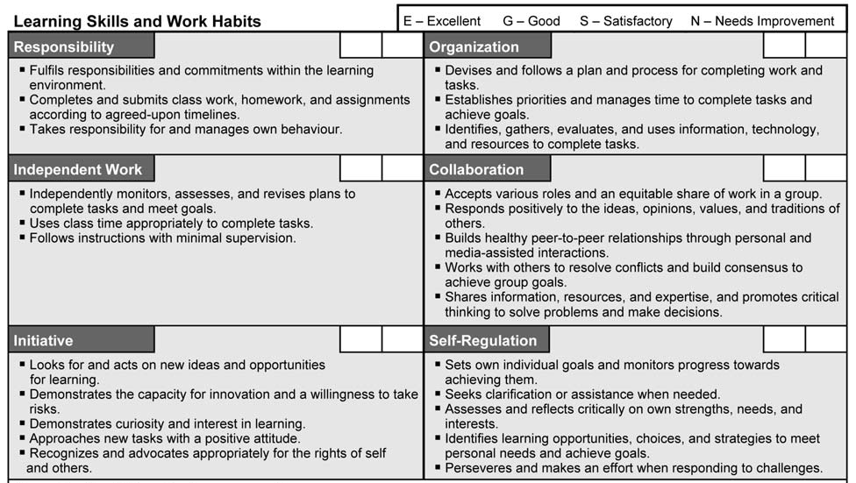

**Unit Breakdown**