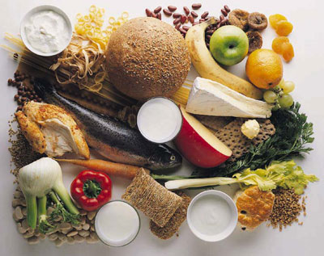MACRONUTRIENTS

**CARBOHYDRATES**

* The body’s main source of ____________________
* Your brain needs a constant supply of carbohydrate to function
* Excess carbohydrate is converted to and stored as fat
* If you don’t eat enough carbs, your body will use the other _______________________ nutrients for ________________.

**Categories of Carbohydrates**

1. **Complex Carbohydrates**

* Broken down into two subcategories: _____________ and _____________________.
* Both are found in grain products, nuts, seeds, legumes, fruits and vegetables
* Dietary Fibre
* Only form of carbohydrate that does not _____________ _____________
* Found only in foods from plant sources
* **Insoluble fibre** promotes regular ____________ _______________ and helps prevent constipation
* **Soluble fibre** may reduce blood _________________ ________________
* You can get enough fibre in your daily diet by: __________________________ _______________________________________________________________

1. **Simple Carbohydrates**

* Another name for simple carbohydrates is: __________________
* These sugars include glucose, fructose, maltose, lactose, sucrose (table sugar)
* Examples of refined sugars:____________________________________________
* Eating large amounts of sweetened foods can lead to ___________

_____________, which can contribute to health problems.

**PROTEINS**

* Used to help the body grow and repair worn-out, damaged parts
* The ‘building blocks’ of the body – made up of chains of chemical building blocks called __________ __________ that are attached together in a long string
* Helps us fight disease
* If you do not consume enough carbohydrates and fat, the body will use protein for energy

**Categories of Protein**

* 1. **Complete** Proteins (animal protein)
     + Proteins that supply all ______ essential amino acids
     + Examples include: ____________________________________________________
  2. **Incomplete** Proteins (plant protein)
* Except for __________________, all foods from plant sources supply incomplete proteins (proteins lacking one or more essential amino acids)
* It is possible to obtain all essential amino acids by eating a variety of foods (especially important for vegetarians)

# FATS

* Provides stored energy for the body
* Concentrated source of energy
* Contains essential fatty acids
* Insulates the body against temperature extremes
* _______________ vital organs like the heart, and liver
* Carries fat-soluble vitamins
* Fat becomes a dietary problem when people consume too much of it. Doing so can increase the risk of illness, such as heart disease and diabetes
* Ways to limit use of fat are: _______________________________, __________________________________________

**Categories of Fat**

1. **Saturated Fat**

* Harmful in excess – work to reduce the amount consumed in diet
* Usually from an animal source
* Examples include: ____________________________________________________

1. **Monounsaturated Fat**

* Healthier source of fat from vegetable sources
* Helps lower cholesterol
* Examples include: ___________________________________________________

1. **Polyunsaturated Fat**

* Healthier source of fat that may also help lower cholesterol
* Examples include: _____________________________________________________

1. **Trans Fat**

* Harmful, especially in excess
* Mostly from processed/ packaged foods, small amounts from animal sources
* Examples include: ­­­­­­­­­­­­­_____________________________________________________

General Rule for Fat:

* Fats that are SOLID at room temperature, such as butter, are made up mainly of saturated fat (or trans fat)
* Fats that are LIQUID at room temperature, such as corn oil or olive oil, are composed primarily of unsaturated fat.

**WATER**

Water is absolutely CRITICAL to life! Most cells in our body contain more than ______ water! Everyone should be drinking at least 8 glasses of water a day.

Water has many functions in our body, including:

* Delivers nutrients to cells
* Helps keep our body temperature normal
* Lubricates joints
* Acts as a shock absorber in our eyes, spinal cord, joints
* Helps our body flush out waste materials