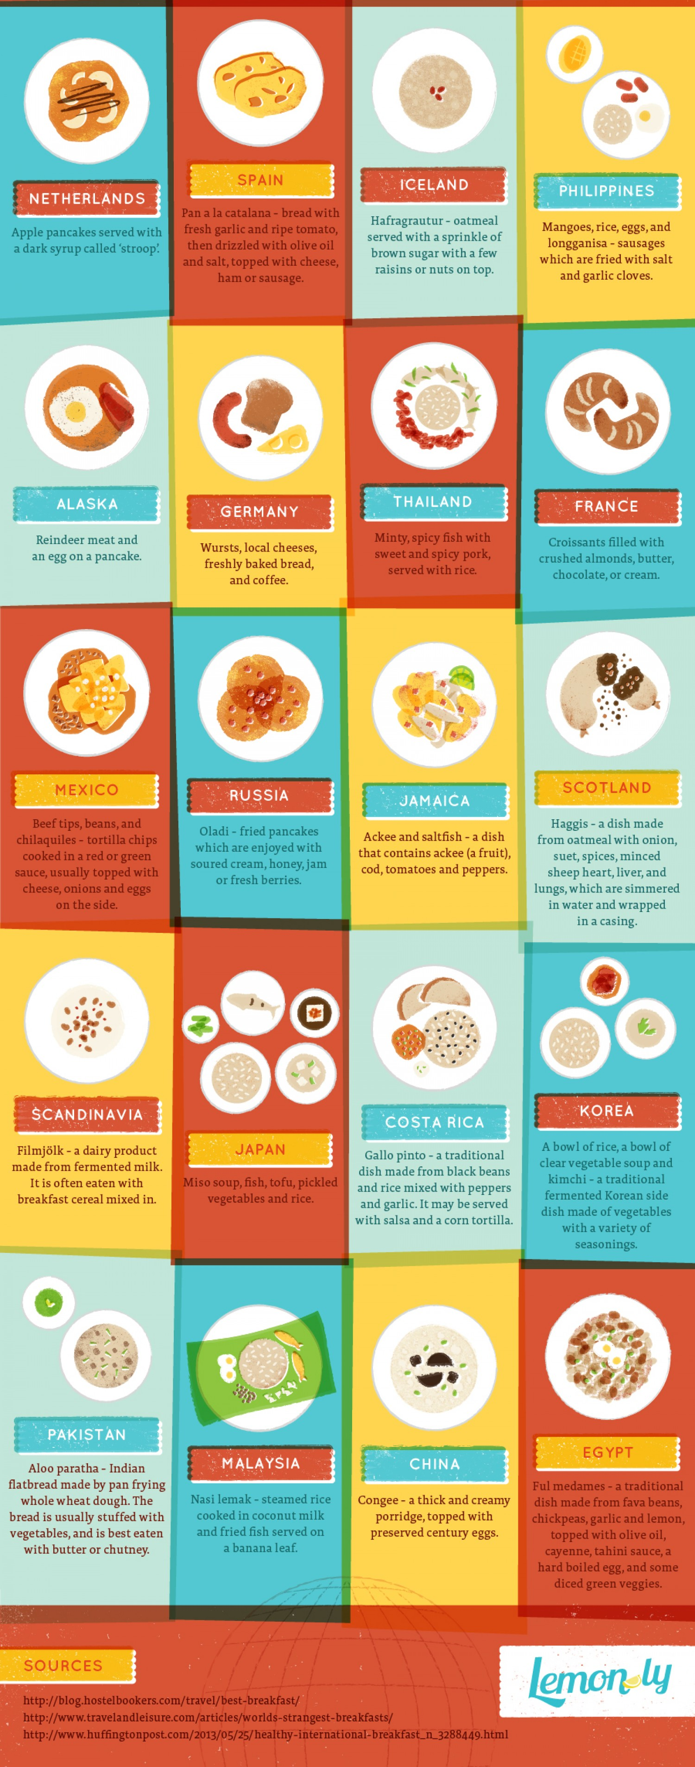

Netherlands

Scandinavia

Spain

Philippines

Alaska

Thailand

Russia

Iceland

Jamaica

Scotland

Germany

Japan

Costa Rica

Korea

France

Pakistan

Malasia

China

Egypt

Mexico

