**Nutrition**

**Nutrition:** the science of ___________________________________

________ you eat, _________ you eat, and how the food you eat affects your body and your health.

Food provides 2 basic needs:

* ________________ is measured in calories and allows your body to perform its many internal functions, such as digestion and heart beating. Energy allows you to move about and lead an active life.
* ________________ are chemicals from food that your body uses to carry out functions, such as to build, maintain and repair tissues

**Energy:**

The number of calories your body needs each day depends on:

* ________________
* ________________
* ________________
* ________________
* ________________

**Estimated Energy Requirements:**

|  |  |  |  |  |
| --- | --- | --- | --- | --- |
| Gender | Age | Activity Levels | | |
| Sedentary | Moderately Active | Active |
| Female | 14-18 years | 1,800 Calories | 2,000 Calories | 2,400 Calories |
| Male | 14-18 years | 2,200 Calories | 2,400-2,800 calories | 2,800-3,200 Calories |

Energy balance and weight **maintenance** occurs when:

________________________ = _________________________

More energy **IN** than **OUT** over time = weight gain

More energy **OUT** than **IN** over time = weight loss

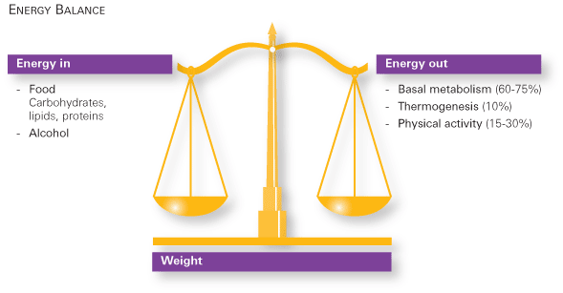

www.nestlenutrition.com

* Don’t ____________ ______________, focus on making healthy food choices using Canada’s Food Guide and leading an active lifestyle.

**Basal Metabolic Rate (BMR):**________________________________________________________________________________________________________________________________________________________________________________________________________

Exercising can increase BMR

Calculate your BMR:__________________________________________________

Calculate your calorie needs: __________________________________________

**Body Mass Index**: Chart to determine appropriate weight for height (is only a guideline – very muscular people can be considered overweight using this chart because muscle weighs more than fat)

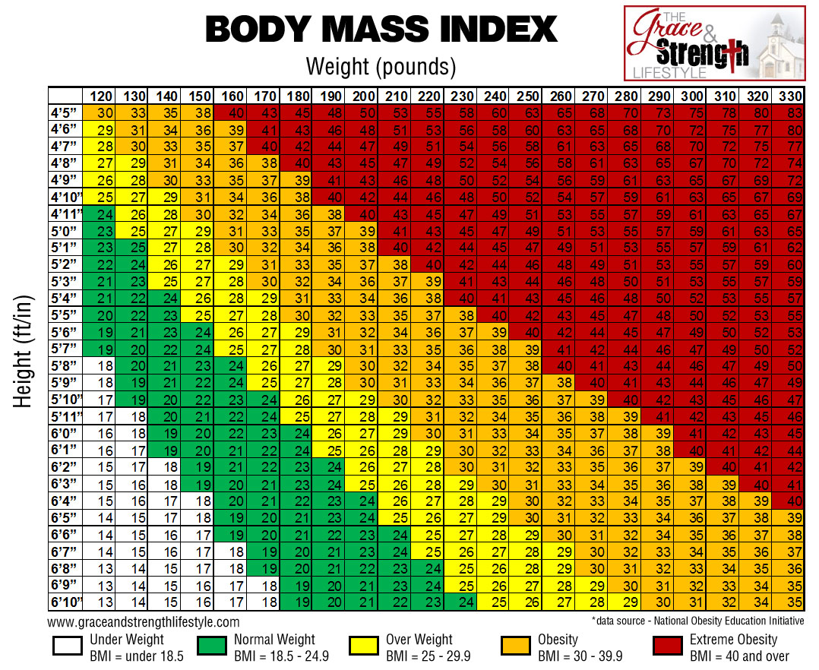

**Nutrients:**

**Six Major Types of Nutrients:**

How can you remember the 6 major types of nutrients?

FPCVMW =

1. Barechadortys = _____________________
2. Tisponer =­__________________
3. Atsf = ___________
4. j0336779j0232977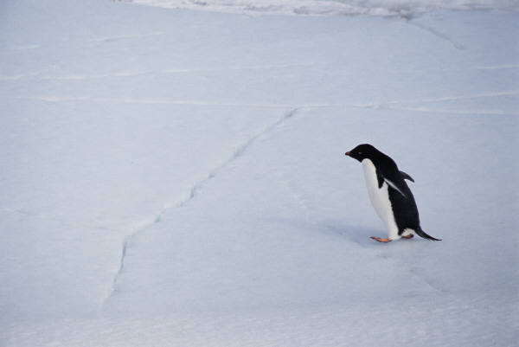Nivastim = ______________
5. Rilmasen = _______________
6. Etwra = _____________

**Macronutrients:** Your body needs in large quantities (> 1 g/ day)

________________ ____________________ __________________ ___________

**Micronutrients:** Your body needs in smaller quantities (< 1 g/day)

____________________ ________________________

**Energy-Containing Nutrients:**

* __________________ provide 4 Calories per gram (multiply grams in a label by 4 to get the number of calories – then divide by total calories and multiply by 100 for percent)
* __________________ provide 4 Calories per gram (multiply grams in a label by 4 to get the number of calories – then divide by total calories and multiply by 100 for percent)
* __________________ provide 9 Calories per gram (multiply grams in a label by 9 to get the number of calories – then divide by total calories and multiply by 100 for percent)

**Energy Source Distribution for Males and Females 14-18 years**

**(Dietary Reference Intakes Acceptable Macronutrient Distribution Range)**



**25-35%**

**45-65%**

**10-30%**

**Empty Calories:**

**Nutrient Dense:**