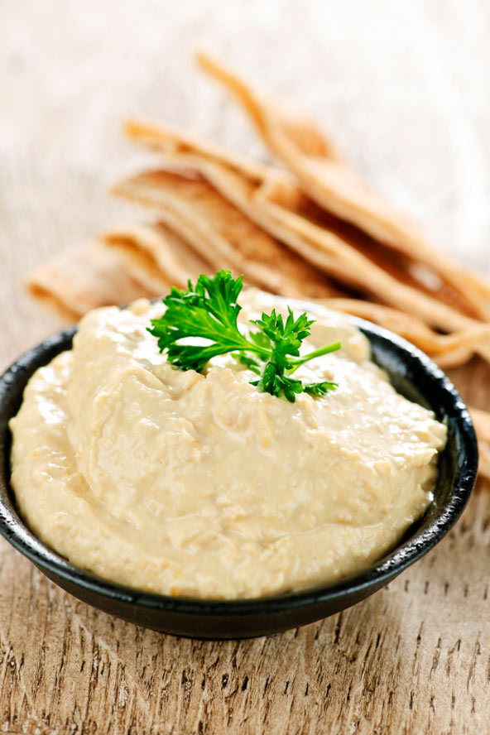
THE HISTORY OF HUMMUS
The word hummus, (which has various spellings) is an Arabic word meaning “chickpea.” Hummus is a Levantine Arab dip or spread that is made from chickpeas (also known as garbanzo beans) that have been cooked and mashed, then blended with tahini (a paste made from sesame seeds), olive oil, lemon juice, garlic and salt. Chickpeas are a vegetable that have been cultivated throughout the Middle East and India for thousands of years. Some sources say that they were growing in the gardens of Babylon.
Many regions around the world claim to be the place where hummus originated. The fact is, that because hummus has been around for so long, and in so many different variations, the exact origin has been lost in antiquity. Several cuisine-related sources speak of a folklore tale in which hummus is described as one of the oldest known prepared foods. Others speak of a legend that hummus was first prepared in the 12th century by Saladin, however this claim is highly disputed.
Despite the fact that the exact known origin of hummus is unclear, we do know that the chickpeas, the main ingredient of hummus, were known to be cultivated in the ancient Mediterranean and the Middle East. Chickpeas have been around for human consumption for several thousands of years. The chickpea was consumed in ancient Palestine, and was one of the earliest crops in Mesopotamia, as well as a common food on the streets of ancient Rome. It is also known that the ancient Greek philosophers Plato and Socrates made reference to the nutritional value of hummus in their writings. Ancient recipes for hummus have also been discovered.
Hummus is a useful food in vegan, vegetarian and non-vegetarian diets. When hummus is eaten with bread it serves as a complete protein, similar to other combinations of grains and legumes. Hummus is high in iron and vitаmin C, and has beneficial amounts of both vitamin B6 and folate. It is also a good source of protein, fiber and potassium. Due to the fact that chickpeas and sesame seeds are so beneficially healthy for us, and that it has been apart of the human diet for thousands of years, it is no wonder hummus has become known as a nutritionist’s delight.
Hummus is available for purchase at most grocery stores, however it is very easy to make. Here is a simple and very tasty recipe for you to try. This recipe only takes a few minutes to prepare, and it is healthier without the oil.
INGREDIENTS
1 (15 ounce) can garbanzo beans (chickpeas), drained, liquid reserved
2 ounces fresh jalapeno pepper, sliced
1/2 teaspoon ground cumin
2 tablespoons lemon juice
3 cloves garlic, minced
DIRECTIONS
In a blender or food processor, combine garbanzo beans, jalapeno, cumin, lemon juice,garlic, and 1 tablespoon of the reserved bean liquid. Blend until smooth. If you prefer a smoother dip, add more of the reserved bean liquid.
Once prepared, all you need to do now is toast some pita bread or heat up some tortillas in a warm oven and dig in. You can also use hummus as a dip for vegetables or a spread on crackers. No matter how you choose to eat it, you can feel good about eating something that not only is healthy for you, but that tastes so delicious.
