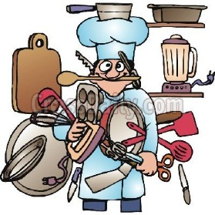
The Right Tool for the Job!
Match the task or technique in the left column with the kitchen tool from the right column that is best choice for that job. Write the letter of the kitchen tool in the space provided. Do not use any tool more than once.
ANSWER | TASK OR TECHNIQUE | KITCHEN TOOLS
 | Lifts and turns flat foods | - Whisk
 | Protects hands when removing items from the oven | - Food processor
 | Slices, chops, dices, minces | - Tongs
 | Eliminates lumps in flour or adds air to dry ingredients | - Chef’knife
 | Protects the counter or table while cutting | - Liquid measuring cup
 | Sautés onions and garlic | - Springform pan
 | Mixes and whips food by hand | - Flipper
 | Shreds by pressing and rubbing the food against a rough surface | - Colander/strainer
 | Scrapes food from bowls | - Pot
 | Purees a food to make it smooth | - Sifter
 | Cream shortening and sugar | - Loaf pan
 | Remove cob of corn from pot | - Tube pan
 | Measure brown sugar | - Oven mitts
 | Boil noodles | - Kitchen brush
 | Baking a cheesecake | - Skillet/frying pan
 | Removing shreds of the outside skin of a lemon | - Cutting board
 | Brushing butter on pastry | - Sauce pan
 | Measure vegetable oil | - Spatula
 | Baking banana bread | - Grater
 | Making gravy | - Zester
 | Baking an angel food cake | - Stand-up mixer/electric mixer
 | Drain macaroni | - Dry measuring cup

