Unhealthy Eating Patterns
- Anorexia Nervosa
- Bulimia Nervosa
- Binge Eating
- Anorexia Athletica
(Excessive Exercise)
- Orthorexia Nervosa
- Disordered Eating

Mental illnesses that require treatment and lengthy rehabilitation

Definitions:
Anorexia Nervosa
Binge Eating
Bulimia Nervosa

New Eating Disorders
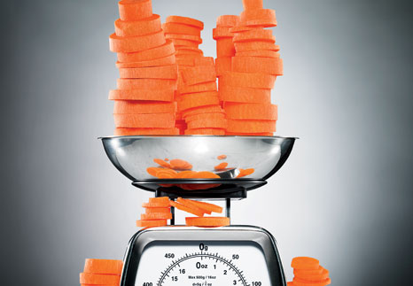
For decades, the eating disorder lexicon had two main entries: anorexia and bulimia. But modern research reveals that these fall woefully short of encompassing the many facets of disordered eating. In the early '90s, the American Psychiatric Association introduced a new diagnostic category: eating disorders not otherwise specified (EDNOS). A catch-all label that includes dozens of subdiagnoses, EDNOS applies to patients who don't meet the exact criteria for anorexia or bulimia but still have very troubled relationships with food or distorted body images. Today, EDNOS diagnoses significantly outnumber anorexia and bulimia cases. "The atypical has become the typical," says Ovidio Bermudez, M.D. These define just a few atypical eating disorders.
Orthorexia
-A fixation with healthy or righteous eating
Orthorexics often eat only organic foods, eliminate entire food groups, or refuse to eat anything that isn't "pure" in quality, says clinical psychologist Sari Shepphird, Ph.D. Unlike anorexics, they don't necessarily think they're fat or strive to be thin; some are motivated by a fear of bad health, a fixation with complete control, or the desire to improve their own self-esteem. Ironically, severe orthorexia can lead to malnourishment.
Pregorexia
-Extreme dieting and exercising while pregnant to avoid gaining the 25 to 35 pounds of weight doctors usually recommend
"There's more social pressure on women to look thin during and after pregnancy," says Shepphird. "But pregorexia comes with very serious health problems." Starving moms-to-be are at risk for depression, anemia, and hypertension, while their malnourished babies are often miscarried or born with birth defects.
Binge Eating
-Compulsive overeating, often to deal with negative emotions or stress
Binge eaters consume large amounts of food very quickly—until they're uncomfortably full. Most sufferers eat in secret to hide their habits. Many feel powerless to stop eating and are disgusted with themselves afterward; but unlike with bulimia, they don't attempt to reverse a binge by vomiting or fasting. While not all patients are overweight, obesity—and its related health problems—are obviously a risk.
"As early as age 30, many women hit a point at which they feel there are certain things they should have accomplished," says Kronberg. "They evaluate their lives, and if they see a void, they look for something that will make them feel good." In essence, a perceived lack of success can morph into a feeling of failure and become an eating disorder catalyst. But emerging research shows that yet another factor could turn an innocent desire for self-improvement into an unstoppable compulsion.
Anorexia Athletica
-An addiction to exercise
Sufferers work out well beyond the requirements for good health, often to the point that their gym time interferes with their job or relationships. "Instead of throwing up, so-called compulsive exercisers purge calories by working out religiously," says Shepphird. "Often, if they don't keep up with their rigorous routine, they feel tremendous anxiety or guilt." They're also at risk for potentially fatal cardiac problems and depression.
Drunkorexia
-Restricting food intake in order to reserve those calories for alcohol and binge drinking
A University of Missouri study found that almost 30 percent of female college students exhibit drunkorexic behavior, "saving" their calories for booze in order to avoid gaining weight or to get drunk faster. Bad idea: These women are upping their chances for alcohol poisoning, uninhibited sexual behavior, and long-term consequences like heart and liver diseases.

